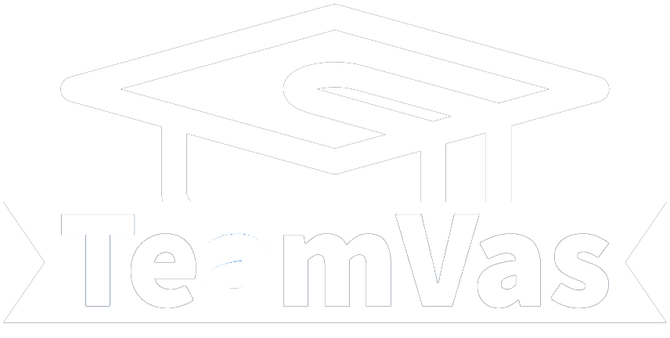**UX-Report**

Contents

Introduction 2

Best practices 2

Design choices 3

User feedback 4

Conclusion 5

# Introduction

In the evolving landscape of web development, The primary objective of this design was to create an interface that is not only visually appealing but also intuitive and user-friendly, catering to the diverse needs of a student as a user. Having similarities to the already existing online education platform Canvas, with some unique changes that would hardly improve the user experience for the end-user.

Throughout this report, Various elements will be listed of the TeamVas design, explaining how each decision was guided by a blend of user feedback research, best practices, design choices and personal creativity. From the overall layout to the finer details of color and typography, each aspect of the frontend was created to provide an engaging and flawless user experience.

# Best practices

Specialized Information Technology company “Value Shore” shared ranking of the best practices for UX design in Web Development ([Top 10 UX](https://www.linkedin.com/pulse/top-10-best-practices-ux-design-web-development-value-shore-doo/)) , the best practices listed in this ranking were used in the creation of UX for TeamVas, some of the best practices listed in this ranking and that were taken into account:

**Clear Navigation Tools**: TeamVas implements a user-friendly and intuitive navigation system. This includes a sticky vertical header for easy access, logically organized buttons with icons, and a prominently placed login/logout button. Such a layout ensures that users can effortlessly find what they are looking for, enhancing the overall user experience.

**Regular Usability Testing**: To continually refine the user experience, TeamVas engages in regular usability testing. This includes techniques like end-to-end testing and capturing real-time user feedback. Such an approach ensures that the application remains user-centric and evolves according to the changing needs and preferences of the end-users.

**Keep It Simple**: The design of TeamVas heavily emphasizes simplicity and clarity. This is reflected in the clean layout, straightforward language, and intuitive user interactions within the application.

# Design choices

In the development of the application, several key design choices were made to enhance user experience and interface aesthetics. At the heart of design, philosophy was the aim to create an environment that is both visually appealing and functionally efficient.

**Color Scheme Purple/White Interface**: a purple and white color scheme was chosen for the user interface. Purple is often associated with creativity, wisdom, and sophistication, which aligns perfectly with the innovative and forward-thinking nature of an online education platform. It stands out without being overpowering, providing a sense of luxury and quality. The white background offers a clean look, providing readability and focusing user attention on the essential elements of the interface. This combination creates a modern and elegant appearance that is both inviting and calming to users.

**Use of Icons**: To improve user navigation and intuitiveness, icons were placed into the vertical navigation-bar. Icons are a universal language in design. By using icons, key functionalities and features are easily identifiable, making the overall usability of the application better. This visual approach helps in creating a more engaging user experience, accessible for international students.

**Notification Alerts with Toastify**: For notification alerts, Toastify was integrated. This choice was driven by the need for communication with users. Toastify alerts appear in a non-blocking manner, ensuring that the user’s workflow is not interrupted. These alerts are brief and concise, providing essential information like confirmation of actions taken and warnings.

**SweetAlert for Deletion Confirmations**: When it comes to critical actions like deleting items, SweetAlert was implemented for confirmation prompts. This was a strategic choice to enhance user safety and prevent accidental deletions. SweetAlert provides a clear and interactive way to confirm such actions. Its visually appealing interface for alerts adds to the overall design of the application while ensuring that important actions are handled with the necessary caution and user confirmation.

# User feedback

Feedback from non-technical users were collected to further improve the user experience and design of the frontend. These users were my parents, they tested the applications flow and executed several tasks that were of importance to the application. Feedback was gathered and used in the improvement of the UX and design. The feedback given was:

User 1 (mom):

"I really like the colors you've chosen for the website. The purple and white make it look inviting. It's easy on the eyes, and I don't feel overwhelmed when I'm looking at different sections. Also, the big buttons and icons you used in the menu are really helpful. I like the alerts you get when you perform certain actions, this helps me to know whether an action actually happened."

User 2 (dad):

"The first thing I noticed when I opened your site was how clean and organized everything looks. It’s not cluttered with too much information, which makes it easier for me to find what I need. When I had to delete something, that warning message asking for confirmation was really reassuring. It's nice to know I won’t accidentally remove something important."

The feedback was not only positive however, User 1 provided critique on the navigation bar, the initial critique being: "I found the text in the menu a bit too small for reading. It was hard to see what each page consisted of". After this feedback the text size in the navigation bar was enlarged, the icons above the text were also made larger.

# Conclusion

In conclusion, the development of TeamVas was aided by combining technical expertise with real-world user feedback. It highlights the importance of empathy in design, where every element is created with an end-user in mind. The completion of the UX report for TeamVas provided knowledge in creating a friendly user interface.

The blending of practices from “Value Shore” laid a strong foundation for the design of TeamVas. Were feedback from real users provided fine end-user changes in the frontend. And listing the design choices helped in understanding how the second frontend build could also fit these interface aesthetics.